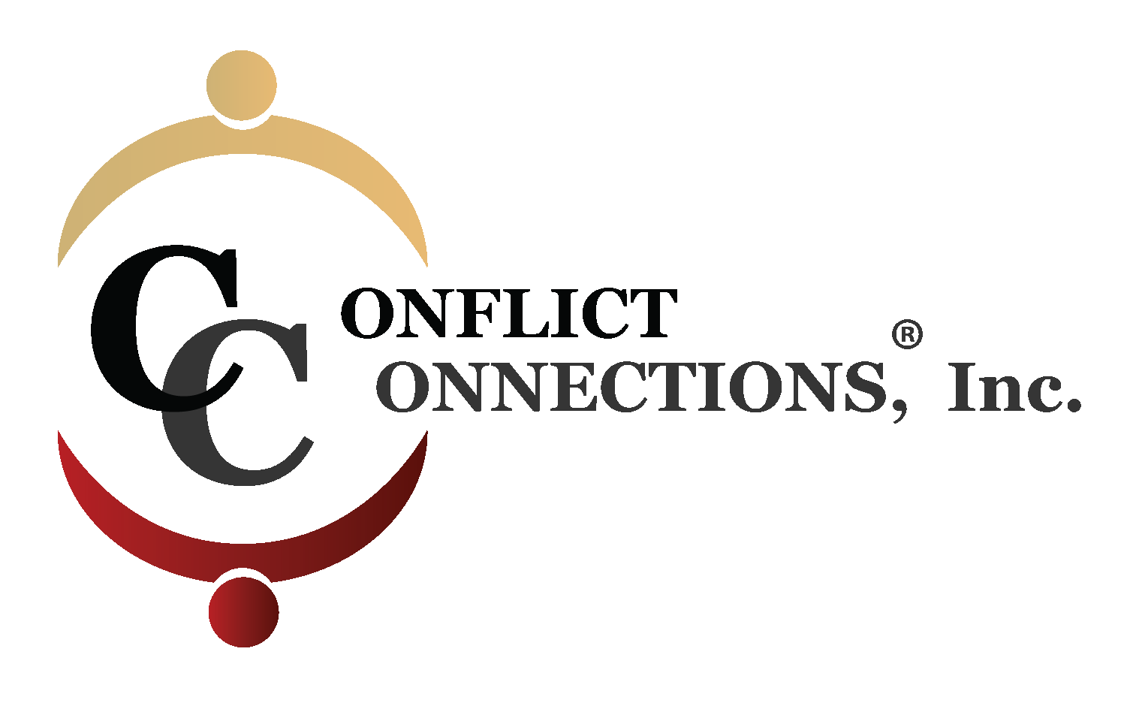
CONFLICT MANAGEMENT COACHING - VIRTUAL TRAINING
SPRING 2022 - REGISTRATION FORM

First Name: __________________________________________________
Last Name: ___________________________________________________
Organization: ____________________________________________________
Street address: __________________________________________________
City:________________________________________________
State/Province: ___________________ Zip code: _____________________
Country: ______________________________
Telephone: _______________________ Cell: ______________________
E-mail: __________________________________
How did you hear about this workshop?____________________________

Early Bird Registration: $1,875.00 USD (no later than February 16, 2022)

Regular Registration: $1,925.00 USD (beginning February 17, 2022)
Required Course Materials:
Student to purchase Conflict Management Coaching: The CINERGY™ Model by Cinnie Noble on Amazon (soft cover or Kindle available)

Cancellation Policy:
For any cancellations received after February 16, 2022, there will be no refund, unless a replacement is found by the applicant. There are no refunds/partial refunds for days missed during the 4-week training period. A $150 administration fee will be charged for cancellations prior to February 16, 2022.
Payment by:
[ ] USD check or money order - make payable to Conflict Connections
[ ] Credit card via Pay Pal or Square
[ ] Bank Wire Transfer (contact pmporter@conflictconnections.com for information)

Send Registration form and payment to:
Conflict Connections, Inc.
13407 Possum Rock, San Antonio, TX 78232

