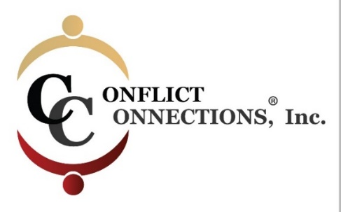
CINERGY® CONFLICT MANAGEMENT COACHING
Spring 2022 VIRTUAL TRAINING
PLEASE KEEP THIS SESSION SCHEDULE

Note: Before registering for class, ensure that you have the time in your schedule to commit to classes and practice times during the training schedule below.
ALL IN-CLASS SESSIONS ARE HELD ON TUESDAYS AND FRIDAYS
Classes begin at 8:00 am Pacific/10:00 am Central/11:00 am Eastern USA
For those outside of the U.S., use the time zone converter here.
Before 1st Day of Class Pre-Reading Required
Session #1 – March 4 2-hour class
Asynchronous Self-Study Between 1-2 hours
Session #2 – March 8 2-hour class
Session #3 – March 11 2-hour class
Asynchronous Self-Study Between 2-3 hours
Session #4 – March 15 2-hour class
Session #5 – March 18 2-hour class
Asynchronous Self-Study Between 1-2 hours
Session #6 – March 22 2-hour class
Session #7 – March 25 2-hour class
Asynchronous Self-Study Between 1-2 hours
Session #8 – March 29 2-hour class

INTERCESSION (Between Class) PRACTICE SESSIONS
March 5 – March 14 1.5-hour Intake with Student Coach Partner
(45 minutes each)

Two hours per person – done in pairs from March 11-17
Two hours per person – done in the same pairs from March 18-25
Participants are paired and assigned a CINERGY certified Coach Mentor who guides the coaching practices. Scheduling is coordinated among the three of you using your mutual choice of platform i.e. Zoom, Microsoft Teams, Google Hangouts, etc.

