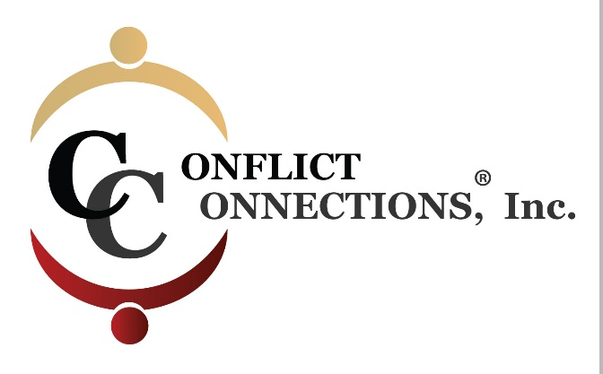
CINERGY® CONFLICT MANAGEMENT COACHING
SPRING 2021 VIRTUAL TRAINING
PLEASE KEEP THIS SESSION SCHEDULE FOR EASY REFERENCE
INTERCESSION (Between Class) PRACTICE SESSIONS
April 2 – April 9 2-hour Intake with Coach Partner
April 16 – April 29 requires a minimum of 4 hours of coach-mentored practice. Practice sessions are outside of class time and mutually scheduled by (2) coaching students and their coach-mentor.
April 30 – May 13 the remaining 4 hours of coach-mentored practice must be completed by the coaching students.
Practice sessions can be coordinated via Skype, Zoom, Google Hangouts, Uber Conference Calling, or phone.

ALL IN-CLASS SESSIONS ARE HELD ON FRIDAYS
Classes begin at 8:00 am Pacific/10:00 am Central/11:00 pm Eastern USA
For those outside of the U.S., use the time zone converter here.
Session #1 – April 2 3-hour class
Session #2 – April 9 2-hour class
Session #3 – April 16 3-hour class
Session #4 – April 23 2-hour class (end one hour early)
Session #4 – April 30 3-hour class
Session #5 – May 7 3-hour class
Session #6 – May 14 2-hour class (end one hour early)

