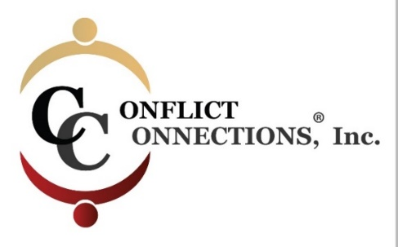
CINERGY® CONFLICT MANAGEMENT COACHING
LATE SUMMER 2022 VIRTUAL TRAINING
PLEASE KEEP THIS SESSION SCHEDULE

Note: Before registering for class, ensure that you have the time in your schedule to commit to classes and practice times during the training schedule below.
ALL IN-CLASS SESSIONS ARE HELD ON TUESDAYS AND FRIDAYS
Classes begin at 8:00 am Pacific/10:00 am Central/11:00 am Eastern USA
For those outside of the U.S., use the time zone converter here.
Before 1st Day of Class Pre-Reading Required
Session #1 – August 26 2-hour class
Asynchronous Self-Study Between 1-2 hours
Session #2 – August 30 2-hour class
Session #3 – September 2 2-hour class
Asynchronous Self-Study Between 2-3 hours
Session #4 – September 6 2-hour class
Session #5 – September 9 2-hour class
Asynchronous Self-Study Between 1-2 hours
Session #6 – September 13 2-hour class
Session #7 – September 16 2-hour class
Asynchronous Self-Study Between 1-2 hours
Session #8 – September 20 2-hour class

INTERCESSION (Between Class) PRACTICE SESSIONS
Aug 27 – Sept 3 1.5-hour Intake with Student Coach Partner
(45 minutes each)

Two hours per person – done in pairs from September 2-9th
Two hours per person – done in the same pairs from September 10-19
Participants are paired and assigned a CINERGY certified Coach Mentor who guides the coaching practices. Scheduling is coordinated among the three of you using your mutual choice of platform i.e. Zoom, Microsoft Teams, Google Meets, etc.

