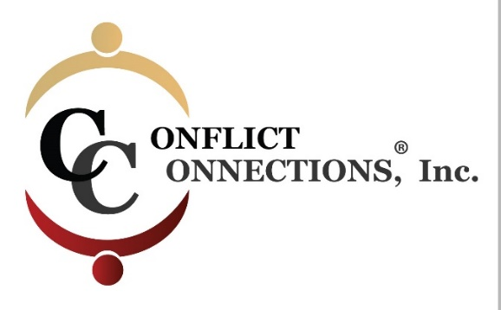
CINERGY® CONFLICT MANAGEMENT COACHING
LATE SUMMER 2021 VIRTUAL TRAINING
PLEASE KEEP THIS SESSION SCHEDULE
ALL IN-CLASS SESSIONS ARE HELD ON FRIDAYS
Classes begin at 8:00 am Pacific/10:00 am Central/11:00 pm Eastern USA
For those outside of the U.S., use the time zone converter here.
Before 1st Day of Class Pre-Reading Required
Session #1 – August 6 2-hour class
Asynchronous Self-Study Between 1-2 hours
Session #2 – August 13 2-hour class
Asynchronous Self-Study Between 1-2 hours
Session #3 – August 20 2-hour class
Asynchronous Self-Study Between 1-2 hours
Session #4 – August 27 2-hour class
Session #5 – September 3 2-hour class
Asynchronous Self-Study Between 1-2 hours
Session #6 – September 10 2-hour class
Asynchronous Self-Study Between 1-2 hours
Session #7 – September 17 2-hour class

INTERCESSION (Between Class) PRACTICE SESSIONS
August 6 – April 12 1.5-hour Intake with Coach Partner
August 20 – September 2 requires a minimum of 4 hours of coach-mentored practice. Practice sessions are outside of class time and mutually scheduled by (2) coaching students and their coach-mentor.
September 3 – September 16 the remaining 4 hours of coach-mentored practice must be completed by the coaching students.
Practice sessions can be coordinated via Skype, Zoom, Google Hangouts, Uber Conference Calling, or phone.

