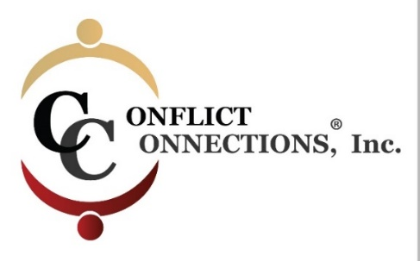
CINERGY® CONFLICT MANAGEMENT COACHING
SUMMER 2023 VIRTUAL TRAINING
PLEASE KEEP THIS SESSION SCHEDULE

Note: Before registering for class, ensure that you have the time in your schedule to commit to classes and practice times during the training schedule below.
INTERCESSION (Between Class) PRACTICE SESSIONS
July 28 – July 31 1.5-hour Intake with Student Coach Partner only
(45 minutes each)
Two hours per person – done in pairs with mentor from August 4th-10th
Two hours per person – done in the same pairs with mentor from August 11-21st
Participants are paired and assigned a CINERGY certified Coach Mentor who guides the coaching practices. Scheduling is coordinated among the three of you using your mutual choice of platform i.e. Zoom, Microsoft Teams, Google, etc.
ALL IN-CLASS SESSIONS ARE HELD ON TUESDAYS AND FRIDAYS
Classes begin at 8:00 am Pacific/10:00 am Central/11:00 am Eastern USA
For those outside of the U.S., use the time zone converter here.
Before 1st Day of Class Pre-Reading Required
Session #1 – July 28 2-hour class
Asynchronous Self-Study Between 1-2 hours
Session #2 – August 01 2-hour class
Session #3 – August 4 2-hour class
Asynchronous Self-Study Between 2-3 hours
Session #4 – August 8 2-hour class
Session #5 – August 11 2-hour class
Asynchronous Self-Study Between 1-2 hours
Session #6 – August 15 2-hour class
Session #7 – August 18 2-hour class
Asynchronous Self-Study Between 1-2 hours
Session #8 – August 22 2-hour class

