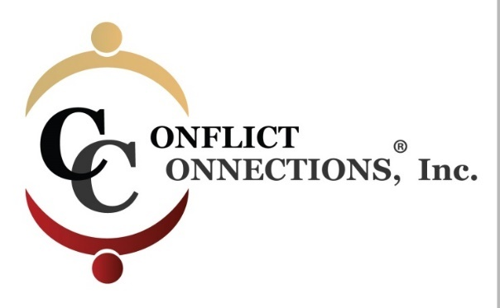

CINERGY® CONFLICT MANAGEMENT COACHING
SPRING 2019 VIRTUAL TRAINING
PLEASE KEEP THIS SESSION SCHEDULE FOR EASY REFERENCE
COACH – MENTOR PRACTICE SESSIONS
March 22 – April 4, 2019 requires a minimum of 4 hours of coach-mentored practice. Practice sessions are outside of class time and mutually scheduled by (2) coaching students and their coach-mentor.
April 5 – April 18, 2019 the remaining 4 hours of coach-mentored practice must be completed.
Practice sessions can be coordinated via Skype, Google Hangouts, Free Conference Calling, or phone.

ALL IN-CLASS SESSIONS ARE HELD ON THURSDAYS
Classes begin at 9:00 pm Pacific/11:00 pm Central/12:00 pm Eastern
For those outside of the U.S., use the time zone converter here.
Session #1 – March 7 3-hour class
Session #2 – March 14 3-hour class
Session #3 – March 21 2-hour class (end one hour early)
NO CLASS on March 28 Coach Mentor Practice Sessions
Session #4 – April 4 3-hour class
Session #5 – April 11 3-hour class
Session #6 – April 18 2-hour class (end one hour early)

