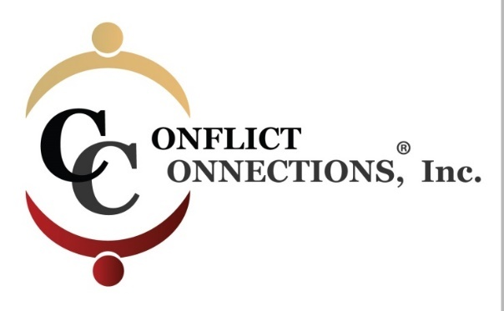

CINERGY® CONFLICT MANAGEMENT COACHING
LATE SUMMER 2020 VIRTUAL TRAINING
PLEASE KEEP THIS SESSION SCHEDULE FOR EASY REFERENCE
COACH – MENTOR PRACTICE SESSIONS
August 21 – September 3, 2020 requires a minimum of 4 hours of coach-mentored practice. Practice sessions are outside of class time and mutually scheduled by (2) coaching students and their coach-mentor.
September 4 – September 18 the remaining 4 hours of coach-mentored practice must be completed.
Practice sessions can be coordinated via Skype, Zoom, Google Hangouts, Uber Conference Calling, or phone.

ALL IN-CLASS SESSIONS ARE HELD ON FRIDAYS
Classes begin at 9:00 am Pacific/11:00 am Central/1:00 pm Eastern USA
For those outside of the U.S., use the time zone converter here.
Session #1 – August 7 3-hour class
Session #2 – August 14 3-hour class
Session #3 – August 21 2-hour class (end one hour early)
NO CLASS on August 28th Coach Mentor Practice Sessions
Session #4 – September 4 3-hour class
Session #5 – September 11 3-hour class
Session #6 – September 18 2-hour class (end one hour early)

