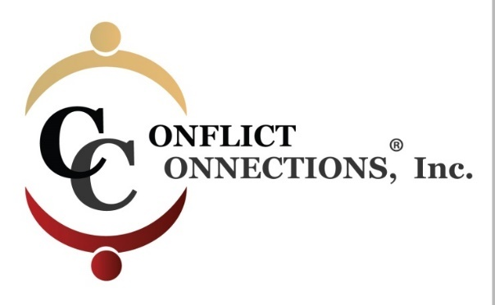

CINERGY® CONFLICT MANAGEMENT COACHING
LATE SUMMER 2019 VIRTUAL TRAINING
PLEASE KEEP THIS SESSION SCHEDULE FOR EASY REFERENCE
COACH – MENTOR PRACTICE SESSIONS (Total of 8 Hours)
August 15 – August 28, 2019 requires a minimum of 4 hours of coach-mentored practice. Practice sessions are outside of class time and mutually scheduled by (2) coaching students and their coach-mentor.
August 29 – September 12, 2019 the remaining 4 hours of coach-mentored practice must be completed.
Practice sessions can be coordinated via Skype, Google Hangouts, Free Conference Calling, or phone.

ALL IN-CLASS SESSIONS ARE HELD ON THURSDAYS
Classes begin at 3:30 pm Pacific/5:30 pm Central/6:30 pm Eastern
For those outside of the U.S., use the time zone converter here.
Session #1 – August 1 3-hour class
Session #2 – August 8 3-hour class
Session #3 – August 15 2-hour class (end one hour early)
NO CLASS on August 22 Coach Mentor Practice Sessions
Session #4 – August 29 3-hour class
Session #5 – September 5 3-hour class
Session #6 – September 12 2-hour class (end one hour early)

