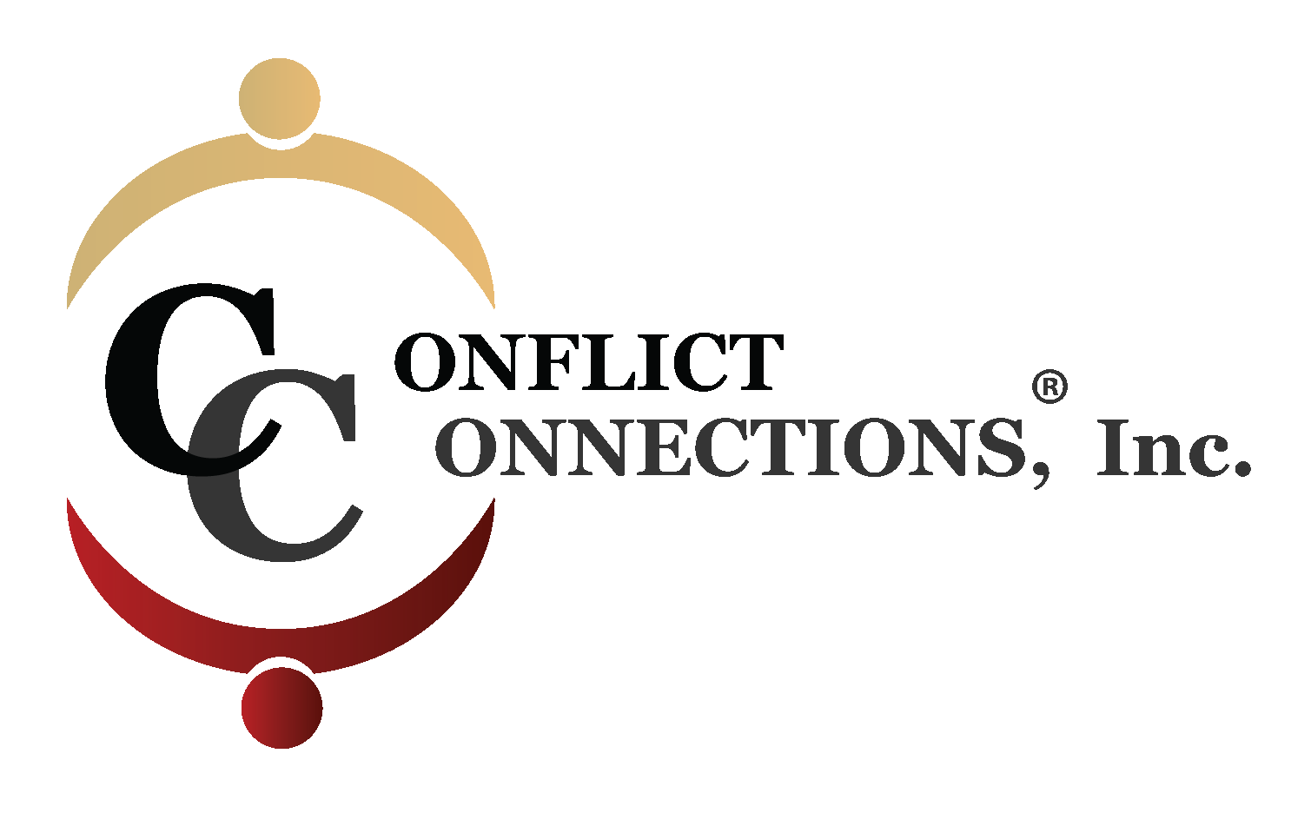
CONFLICT MANAGEMENT COACHING VIRTUAL TRAINING

A virtual training is goal-oriented, web-based, instructor-led, interactive and synchronous. Students may participate from any location. It requires hardware (computer), audio (required headset), webcam, and good bandwidth.

This online training is a licensed conflict management coaching course approved by Cinnie Noble, CINERGY® with credit from the International Coach Federation and Society for Human Resource Management (SHRM). Students learn a one-on-one process in which a trained coach assists people to effectively prevent or manage interpersonal disputes and to enhance their conflict management skills. It may be used before and after a conflict has arisen, or while it is in progress. This process has wide application. Conflict management coaching may be applied in organizational, family and other contexts and for coaching individuals to participate in mediation and negotiation.

Course Outcomes:

After completing this intense 7-week virtual training course, participants will be able to:
- Prepare a client for conflict coaching using an intake process
- Describe how to deconstruct and analyze an interpersonal conflict
- Use the 7-stage CINERGY® coaching model
- Assess their own conflict triggers and behavioral responses
- Use various listening and questioning techniques to guide the client
- Observe and give effective client feedback
- Analyze ethical challenges and decide what is an appropriate strategy
- Develop a plan for next steps in their coaching practice

Continuing Education:
Participants completing the course will receive the CINERGY® Certificate of Completion for 24 hours. This virtual training has also been approved for 26 hours of Continuing Coaching Education Units from the International Coach Federation (20 hours ICF Core Competencies & 6 hours Resource Development). Mandatory attendance and/or reading is required to earn the full 26 hours of ICF CEU credit.
CINERGY is an approved SHRM Recertification Provider. This program is valid for 24 PDCs for the SHRM-CPSM or SHRM-SCPSM.
For more information, send an email to pmporter@conflictconnections.com or phone (210) 880-4440 or visit our website at www.conflictconnections.com

COURSE LOGISTICS
SMALL CLASS SIZES (NO MORE THAN 10)
Senior Trainer: Patricia “Pattie” Porter, LCSW, AAP, ABW is a certified Advanced Conflict Management Coach, coach-mentor, competency assessor, and a licensed trainer of the CINERGY® conflict management coaching model. Cinnie Noble is a pioneer in the field of conflict management coaching, and the founder of the CINERGY® model, which is taught worldwide.
Technical Prep/Test Session (Mandatory): Dates To Be Announced one week prior to class
7 – week Course: Thursdays, August 1 – September 12, 2019 (5:30 pm – 8:30 pm Central)
Class Schedule: See detailed class schedule of days, times and required practice sessions outside of class. (All class sessions will be recorded.)
Required Course Materials:
- Student to purchase Conflict Management Coaching: The CINERGY™ Model by Cinnie Noble
Pre-requisite Reading: Noble’s book, Chapters 2 and 4
- Course manual to be provided to each student
Optional Book: Conflict Mastery: Questions to Guide You (2014) or Conflict Mastery Workbook by Cinnie Noble
Training Cost: $1499.00 USD (prior to July 18, 2019) and $1549.00 USD (after July 18, 2019)
Register and pay online at http://www.conflictconnections.com/conflict-management-coaching-on-line.html

VIRTUAL TRAINING TECHNICAL REQUIREMENTS
This is a highly interactive, virtual training conducted online through Adobe Connect meeting platform. To participate in this environment, you will need the following:
- Computer
- Headset required (phone as backup)
- Webcam (built in or attachable)
- Possible Adobe Flash plug-in software updates
- Solid bandwidth (preferably hard-wired to your modem)
The mandatory technical session is intended to provide technical support and familiarity with the platform to ensure participant’s computer systems (audio and visual) are compatible, and they know how to work within the virtual environment.
Each participant is responsible for assuring they have the right equipment and that it is in working order prior to the first training day. Adobe Connect Platform offers 24/7 technical support. Call their toll free #800-945-9120 and follow the prompts. Once the training begins, NO REFUND will be given to participants because of technical difficulties.
Use this link to test your computer system.
https://admin.adobeconnect.com/common/help/en/support/meeting_test.htm

