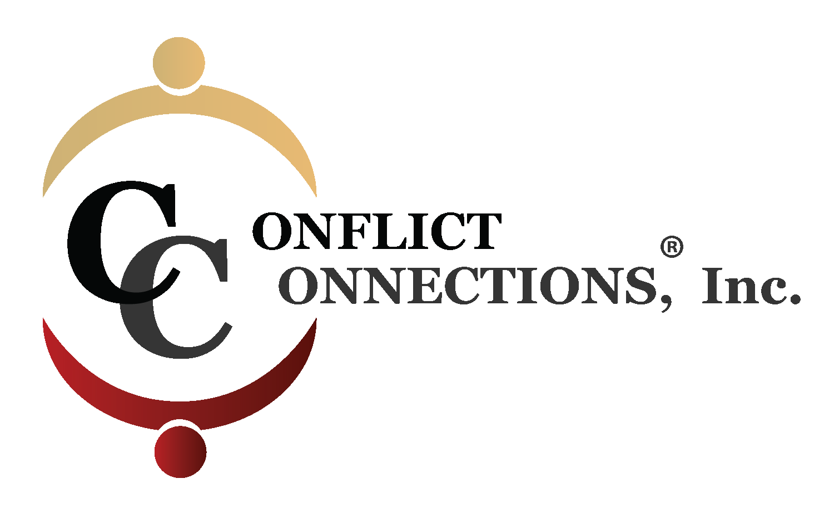
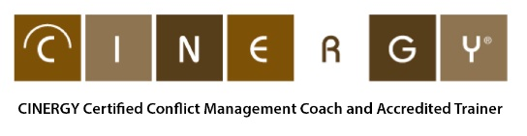

CONFLICT MANAGEMENT COACHING VIRTUAL TRAINING
This online training is a licensed conflict management coaching course approved by Cinnie Noble, CINERGY® with credit from the International Coaching Federation and Society for Human Resource Management (SHRM). Students learn a one-on-one process in which a trained coach assists people to effectively prevent or manage interpersonal disputes and to enhance their conflict management skills. It may be used before and after a conflict has arisen, or while it is in progress. This process has wide application. Conflict management coaching may be applied in organizational, family, and other contexts and for coaching individuals to effectively participate in mediation, negotiation and relational conflicts. Cinnie Noble is a pioneer in the field of conflict management coaching, and the founder of the CINERGY® model, which is taught worldwide.

Course Outcomes:

After completing this immersive 4-week virtual training course, participants will be able to:
- Prepare a client for conflict coaching using an intake process
- Describe how to deconstruct and analyze an interpersonal conflict
- Use the 7-stage CINERGY® coaching model both as a coach, ‘client’ and observer
- Assess your own conflict triggers and behavioral responses
- Use various listening and questioning techniques to guide the client
- Observe and give effective client input
- Acknowledge the Ethical Code of Practice for Conflict Coaches
- Develop a plan for next steps in their coaching practice

Accredited Senior Trainer: Patricia “Pattie” Porter, LCSW, PCC, ABW is a certified Advanced Conflict Management Coach, coach-mentor, competency assessor, and a licensed trainer of the CINERGY® conflict management coaching model. Since 2009, Pattie taught this course to students from over 16 countries. She currently teaches this course at the graduate level in the Dispute Resolution Program at Southern Methodist University in Dallas, Texas.

Methods of Instruction:

A virtual training is immersive “Master Class” that is goal-oriented, web-based, instructor-led, interactive with synchronous class times and asynchronous self-study (readings and video demonstrations). Small class size with no more than twelve students. Students may participate from any global location. It requires hardware (computer), audio (required headset), webcam, and good bandwidth. This virtual class training uses the Zoom platform. Participants engage in small group discussions, active learning during demonstrations, individual reflection, skills practices, mini quizzes through polls, and mini-lecture. Outside of class time, students partner with a student and a CINERGY accredited Coach Mentor for 8 hours of extensive practice of the model using their chosen interpersonal dispute. See Session Schedule for more details.

Note: Class sessions are not recorded. A student, if needs be, can be excused for a total of 4 hours of class with 24 hours advanced notice. Those sessions can be recorded for review. Missing a class and watching the recording does not earn you ICF CEUS as you must be present during the live class to earn those hours.
Course Materials Required:
- Student to purchase Conflict Management Coaching: The CINERGY™ Model by Cinnie Noble on Amazon (soft cover or Kindle available)
- Optional purchase: Conflict Mastery: Questions to Guide You (2014) or Conflict Mastery Workbook by Cinnie Noble via Amazon
- Student receives a course manual used extensively in classes and during practice sessions

Continuing Education:
Participants completing the course will receive the CINERGY® Certificate of Completion for up to 31 hours. The International Coaching Federation (ICF) approved up to 33 hours of CEUs for this course. (30 hours of core competencies and 3 hours of Resource Development). Students can earn additional 2 hours for reading and a successfully completing a questionnaire prior to the first day of class.

To earn ICF credit, students must attend synchronous classes, view video demonstrations, and engage in the coach practice sessions. Missed time results in the deduction of CEU hours on the certificate.

CINERGY® is an approved SHRM Recertification Provider. This program is valid for 30 PDCs for the SHRM-CP or SHRM-SCP.
For more information, send an email to pmporter@conflictconnections.com or phone (210) 880-4440 or visit our website at www.conflictconnections.com

